Week 1: Role clarity and setup
Difficulty: Beginner · Time: ≈19 hrs
☐ 1.1 Understand the FDE role (4 hrs)
- Objective: Explain what FDEs do and how the role differs from software engineer, solutions engineer, and consultant.
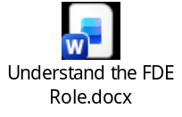
- Steps:
  - Read Palantir’s blog post “A Day in the Life of a Palantir Forward Deployed Software Engineer”.
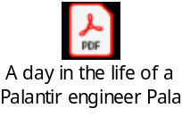
  - Read 5 current FDE job descriptions (Palantir, OpenAI, Anthropic, Databricks, Scale AI careers pages).
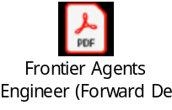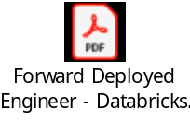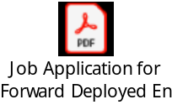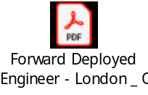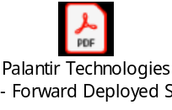
  - List the recurring skills and responsibilities.
Recurring Skills & Core Responsibilities Across FDE Roles
Based on the job descriptions from Scale AI, OpenAI, Anthropic, Databricks, and Palantir, here is a breakdown of the core skills and responsibilities that consistently define the Forward Deployed Engineer role:
Key Responsibilities
- Enterprise System & Agent Architecture
  - Architecting end-to-end full-stack applications and distributed systems that combine LLMs, retrieval systems (RAG), vector databases, memory, and tool integration.
  - Building production components like Model Context Protocol (MCP) servers, sub-agents, and execution services integrated into existing customer IT software.
- Customer Embedding & Technical Scoping
  - Embedding directly with strategic customer teams and domain experts to translate ambiguous requirements into technical system designs.
  - Leading technical architecture discussions, scoping deliverables, and aligning strategies with both technical ICs and C-level executives.
- Production-Grade Implementation & Integration
  - Writing high-quality, production-ready backend, frontend, and data pipeline code (Python, TypeScript, SQL, Java/Scala).
  - Integrating AI agents with enterprise data pipelines, customer databases, and security/governance compliance frameworks.
- Production Quality, Observability & Evals
  - Deploying AI evaluation harnesses (offline benchmarks, golden datasets, regression suites, LLM-as-a-Judge) to detect quality regressions.
  - Setting up system observability, tracing, guardrails, fallback strategies, latency optimization, and human-in-the-loop workflows.
- Feedback Loop & Reusable Frameworks
  - Identifying recurring customer challenges and turning them into reusable assets, accelerators, and deployment playbooks.
  - Sharing field insights directly back to internal Research, Product, and Engineering teams to influence core platform roadmaps.
Recurring Technical & Soft Skills
- Software Engineering Fundamentals: Strong background in distributed systems, data structures, algorithms, system design, and API development.
- Programming Languages: Skills list says Python is required or strongly preferred in 4 of 5. Palantir lists it as one option among Java, C++, TypeScript and Palantir is language-flexible.
- Modern AI Tech Stack: Practical experience with LLM APIs, agent orchestration frameworks, vector databases, retrieval systems, and prompt engineering.
- Infrastructure & Cloud Platforms: Experience with major cloud providers (AWS, Azure, GCP), Docker, Kubernetes, CI/CD pipelines, and cloud-native architectures.
- High Agency & Navigating Ambiguity: Ability to operate independently with minimal direction, manage trade-offs under high stakes, and pivot rapidly in complex organizations.
- Dual Fluency / Technical Communication: Strong interpersonal and written communication skills to bridge deep technical systems engineering with executive business impact.
- Willingness to Travel: Palantir, OpenAI, Anthropic and Databricks mention travel (25-50%). The Scale AI posting does not.

- Resources: Palantir blog (blog.palantir.com); company careers pages.
- Exercise: Write a one-page “FDE role map”: a table of responsibilities, skills, and typical customer situations.
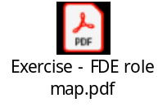
- Checkpoint: You can explain the role, and how it differs from similar roles, in two minutes without notes.
Script is ready
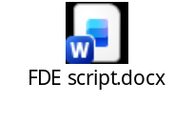
☐ 1.2 Set up your development environment (5 hrs)
- Objective: Have a working, version-controlled workspace.
- Steps:
  - Install VS Code, Python 3.12+, Git.

VS Code

Version: 1.133.0 (user setup)
Commit: a5b500951314efd502d07465bd138dfbd714a960
Date: 2026-08-11T22:14:08Z
Electron: 42.8.0
ElectronBuildId: 14845705
Chromium: 148.0.7778.280
Node.js: 24.18.0
V8: 14.8.178.38-electron.0
@github/copilot: 1.0.79-6
@github/copilot-sdk: 1.0.9
OS: a5b500951314efd502d07465bd138dfbd714a960
Python
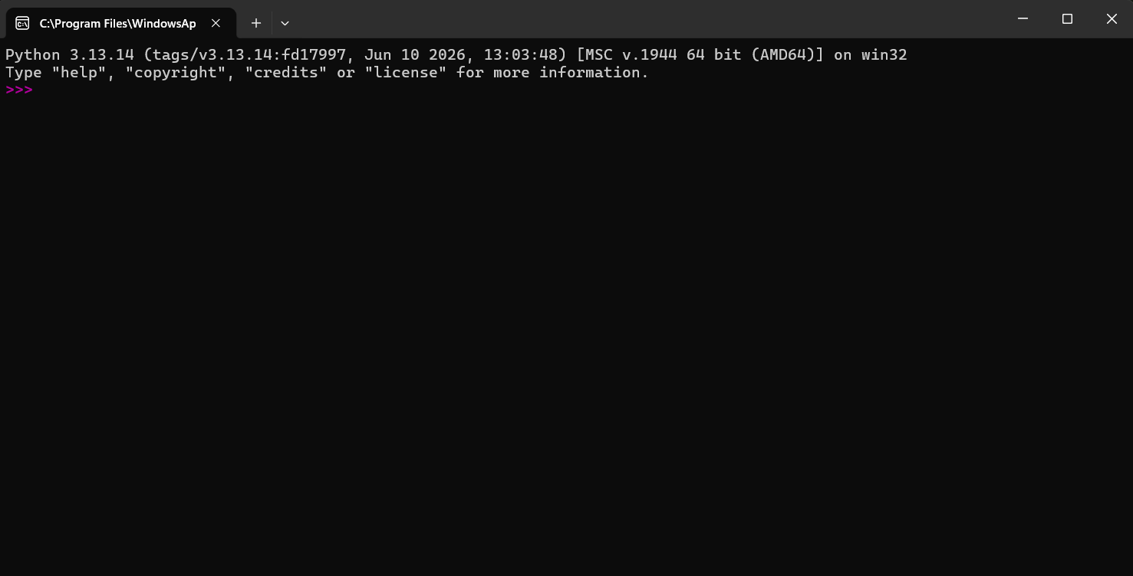

GitHub
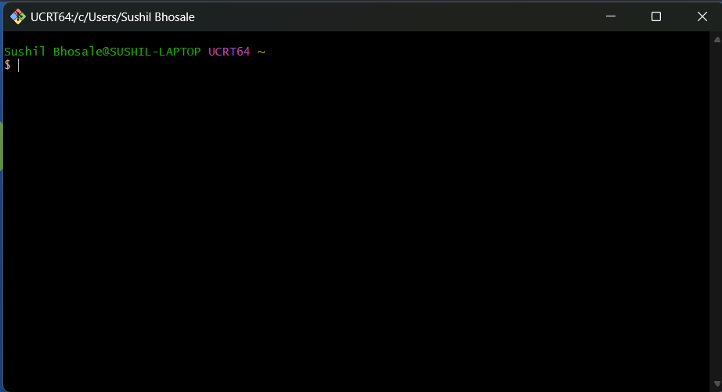
(2) Create a GitHub account. (3) Create a repo called fde-journey with a README and a journal/ folder. (4) Make your first commit from the terminal.
- Resources: code.visualstudio.com; python.org/downloads; docs.github.com/en/get-started.
- Exercise: Write and run a “hello world” script, then commit and push it.
Sushil Bhosale@SUSHIL-LAPTOP UCRT64 ~/fde-journey (main)
$ git push
Enumerating objects: 6, done.
Counting objects: 100% (6/6), done.
Delta compression using up to 8 threads
Compressing objects: 100% (3/3), done.
Writing objects: 100% (5/5), 459 bytes | 459.00 KiB/s, done.
Total 5 (delta 0), reused 0 (delta 0), pack-reused 0 (from 0)
To https://github.com/SushilB2402/fde-journey.git
c698271..4e61f9b main -> main

Sushil Bhosale@SUSHIL-LAPTOP UCRT64 ~/fde-journey (main)
$ ls
README.md notes/ projects/ resources/

Sushil Bhosale@SUSHIL-LAPTOP UCRT64 ~/fde-journey (main)
$ mkdir -p week1

Sushil Bhosale@SUSHIL-LAPTOP UCRT64 ~/fde-journey (main)
$ echo 'print("Hello, world!")' > week1/hello.py

Sushil Bhosale@SUSHIL-LAPTOP UCRT64 ~/fde-journey (main)
$ python week1/hello.py
Hello, world!

- Checkpoint: Your first commit is visible on GitHub.
Sushil Bhosale@SUSHIL-LAPTOP UCRT64 ~/fde-journey (main)
$ gh api repos/SushilB2402/fde-journey/commits --jq '.[] | .sha[0:7] + " " + .commit.message'
08fbb21 Add hello world script
4e61f9b Add folder structure
c698271 Initial commit

☐ 1.3 Python basics, part 1 (7 hrs)
- Objective: Write simple Python programs with variables, conditionals, loops, and functions.
- Steps: (1) Start CS50’s Introduction to Programming with Python and complete lectures 0-2. (2) Do every problem set.
- Resources: cs50.harvard.edu/python (free); docs.python.org/3/tutorial.
- Exercise: Write 10 small scripts (unit converter, word counter, and so on) and commit them.
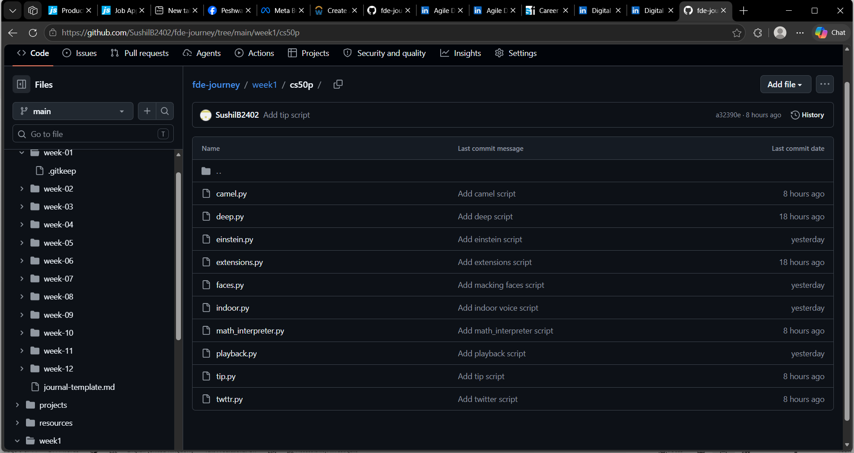
  - Indoor Voice - indoor.py
# Convert message 'HELLO, WORLD' from capital to small 'hello, world'
message = input("Enter a message in capital letters: ")
print(message.lower())

Result:
Enter a message in capital letters: HELLO, WORLD
hello, world

  - Playback Speed - playback.py
# Prompt the user for input and replace each space with three periods (...)
text = input("Enter text: ")
print(text.replace(" ", "..."))

Result:
Enter text: This is CS50.
This...is...CS50.

  - Making Faces - faces.py
def convert(text):
text = text.replace(":)", "🙂")
text = text.replace(":(", "🙁")
return text

def main():
user_input = input("Input: ")
result = convert(user_input)
print(result)

if __name__ == "__main__":
main()

Result:
Input: Hello :), Goodbye :(
Hello 🙂, Goodbye 🙁

  - Einstein – einstein.py
# Prompt the user for mass in kilograms
mass = int(input("m: "))

# Speed of light in meters per second
c = 300000000

# Calculate energy using E = mc^2
energy = mass * (c ** 2)

# Output the equivalent energy in Joules
print(energy)

Result:
m: 10
900000000000000000

  - Tip Calculator – tip.py
def main():
dollars = dollars_to_float(input("How much was the meal? "))
percent = percent_to_float(input("What percentage would you like to tip? "))
tip = dollars * percent
print(f"Leave ${tip:.2f}")

def dollars_to_float(d):
# Removes the leading '$' and converts the remaining string to afloat
return float(d.replace("$", ""))

def percent_to_float(p):
# Removes the trailing '%' and converts to a float decimal (divided by 100)
return float(p.replace("%", "")) / 100

main()

Result (both works):
How much was the meal? 15
What percentage would you like to tip? 25
Leave $3.75

Or

How much was the meal? $15
What percentage would you like to tip? 25%
Leave $3.75

  - Deep Thought - deep.py
def main():
# Prompt the user for the answer
answer = input("What is the Answer to the Great Question of Life, the Universe and Everything? ")

# Clean and check the input case-insensitively
answer = answer.strip().lower()

if answer in ["42", "forty-two", "forty two"]:
print("Yes")
else:
print("No")

if __name__ == "__main__":
main()

Result:
PS C:\Users\Sushil Bhosale\fde-journey\week1\cs50p> python deep.py
What is the Answer to the Great Question of Life, the Universe and Everything? 42
Yes
PS C:\Users\Sushil Bhosale\fde-journey\week1\cs50p> python deep.py
What is the Answer to the Great Question of Life, the Universe and Everything? forty two
Yes
PS C:\Users\Sushil Bhosale\fde-journey\week1\cs50p> python deep.py
What is the Answer to the Great Question of Life, the Universe and Everything? forty-two
Yes
PS C:\Users\Sushil Bhosale\fde-journey\week1\cs50p> python deep.py
What is the Answer to the Great Question of Life, the Universe and Everything? 50
No
PS C:\Users\Sushil Bhosale\fde-journey\week1\cs50p> python deep.py
What is the Answer to the Great Question of Life, the Universe and Everything? Fifty-five
No

  - File Extensions - extensions.py
def main():
filename = input("File name: ").strip().lower()

if filename.endswith(".gif"):
print("image/gif")
elif filename.endswith(".jpg") or filename.endswith(".jpeg"):
print("image/jpeg")
elif filename.endswith(".png"):
print("image/png")
elif filename.endswith(".pdf"):
print("application/pdf")
elif filename.endswith(".txt"):
print("text/plain")
elif filename.endswith(".zip"):
print("application/zip")
else:
print("application/octet-stream")

if __name__ == "__main__":
main()

Result:
PS C:\Users\Sushil Bhosale\fde-journey\week1\cs50p> python .\extensions.py
File name: sample.txt
text/plain
PS C:\Users\Sushil Bhosale\fde-journey\week1\cs50p> python .\extensions.py
File name: test.zip
application/zip

  - Math Interpreter - math_interpreter.py
# Prompt user for an arithmetic expression
expression = input("Expression: ")

# Unpack the string by splitting at the spaces
x_str, y, z_str = expression.split(" ")

# Convert operands to integers
x = int(x_str)
z = int(z_str)

# Calculate the result based on the operator
if y == "+":
result = x + z
elif y == "-":
result = x - z
elif y == "*":
result = x * z
elif y == "/":
result = x / z

# Output the result formatted as a floating-point value to one decimal place
print(f"{result:.1f}")

Result:
PS C:\Users\Sushil Bhosale\fde-journey\week1\cs50p> python .\math_interpreter.py
Expression: 1 + 1
2.0
PS C:\Users\Sushil Bhosale\fde-journey\week1\cs50p> python .\math_interpreter.py
Expression: 4 / 3
1.3
PS C:\Users\Sushil Bhosale\fde-journey\week1\cs50p> python .\math_interpreter.py
Expression: 100 - 1
99.0
PS C:\Users\Sushil Bhosale\fde-journey\week1\cs50p> python .\math_interpreter.py
Expression: -1 + 100
99.0

  - camelCase – camel.py
def main():
# Prompt the user for a variable name in camel case
camel_case = input("camelCase: ")

snake_case = ""
for char in camel_case:
# If the character is uppercase, add an underscore and lowercase it
if char.isupper():
snake_case += "_" + char.lower()
else:
snake_case += char

# Output the corresponding name in snake case
print(f"snake_case: {snake_case}")

if __name__ == "__main__":
main()

Result:
PS C:\Users\Sushil Bhosale\fde-journey\week1\cs50p> python .\camel.py
camelCase: name
snake_case: name
PS C:\Users\Sushil Bhosale\fde-journey\week1\cs50p> python .\camel.py
camelCase: firstName
snake_case: first_name
PS C:\Users\Sushil Bhosale\fde-journey\week1\cs50p> python .\camel.py
camelCase: prefferedFirstName
snake_case: preffered_first_name

  - Just setting up my twttr – twttr.py
def main():
user_input = input("Input: ")
print("Output:", omit_vowels(user_input))

def omit_vowels(text):
vowels = "AEIOUaeiou"
result = []
for char in text:
if char not in vowels:
result.append(char)
return "".join(result)

if __name__ == "__main__":
main()

Result:
PS C:\Users\Sushil Bhosale\fde-journey\week1\cs50p> python .\twttr.py
Input: twitter
Output: twttr
PS C:\Users\Sushil Bhosale\fde-journey\week1\cs50p> python .\twttr.py
Input: What's your name?
Output: Wht's yr nm?
PS C:\Users\Sushil Bhosale\fde-journey\week1\cs50p> python .\twttr.py
Input: CS50
Output: CS50
PS C:\Users\Sushil Bhosale\fde-journey\week1\cs50p> python .\twttr.py
Input: Python
Output: Pythn
- Checkpoint: You can write a function from scratch without copying code.
Checkpoint 1 (write a function such as is_even(n)) – checkpoint1.py
def is_even(num):
return num % 2 == 0

number = int(input("Enter a number: "))
if is_even(number):
print(f"{number} is an even number.")
else:
print(f"{number} is an odd number.")
Result:
PS C:\Users\Sushil Bhosale\fde-journey\week1\cs50p> python .\checkpoint1.py
Enter a number: 4
4 is an even number.
PS C:\Users\Sushil Bhosale\fde-journey\week1\cs50p> python .\checkpoint1.py
Enter a number: 7
7 is an odd number.

Checkpoint 2 (converts “3 hours 30 minutes” into minutes) – checkpoint2.py
def convert_hours_to_minutes(hours, minutes):
return hours * 60 + minutes
print(convert_hours_to_minutes(3, 30)) # Output: 210
Result:
PS C:\Users\Sushil Bhosale\fde-journey\week1\cs50p> python .\checkpoint2.py
210
☐ 1.4 Start the learning journal (3 hrs)
- Objective: Build a habit of documenting your reasoning, which is core FDE work.
- Steps: (1) Create a daily or weekly journal template: goal, what I did, what blocked me, next step.
notes/journal-template.md

# Week N Journal

* **Goal this week:** [State your primary objective for the week]

## What I Did
* [List major tasks completed, problem sets solved, or code pushed]

## What Blocked Me
* [Detail error messages, typos, or confusing logic, and how you resolved them]

## What I Learned
* [Key technical concepts, tools, or FDE practices mastered]

## Next Step
* [Immediate next actions or upcoming curriculum goals]

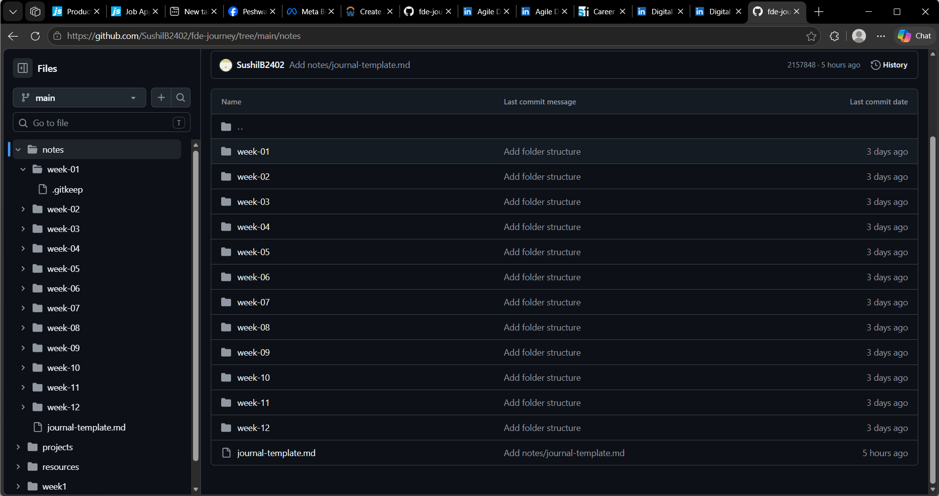
- (2) Write your first entry.
# Week 01 Journal

* **Goal this week:** Complete Week 1 setup—understand the Forward Deployed Engineer (FDE) role, configure the development environment (VS Code, Python 3.13, Git), complete CS50P Lectures 0–2 problem sets, and establish a learning journal habit.

## What I Did
* **Role Mapping:** Analyzed FDE job descriptions across top AI companies (Palantir, OpenAI, Anthropic, Databricks, Scale AI) and synthesized key responsibilities, skills, and differences from SWE/SE/Consultant roles.
* **Environment Setup:** Installed VS Code, Python 3.13.14, and Git/GitHub CLI. Created the `fde-journey` repository and structured folders (`week1/`, `notes/`).
* **Python Practice (CS50P):** Wrote and successfully executed 10 Python scripts covering string manipulation, conditionals, arithmetic operations, functions, and boolean logic:
* `indoor.py` (case conversion with `.lower()`)
* `playback.py` (string replacement with `.replace()`)
* `faces.py` (custom function converting emoticons to emojis)
* `einstein.py` (energy calculation $E = mc^2$)
* `tip.py` (currency and percentage string cleaning to float)
* `deep.py` (case-insensitive string matching)
* `extensions.py` (MIME type matching via `.endswith()`)
* `math_interpreter.py` (expression parsing with `.split()`)
* `camel.py` (converting camelCase to snake_case via loop)
* `twttr.py` (filtering vowels out of strings)
* Checkpoint functions: `checkpoint1.py` (`is_even()`) and `checkpoint2.py` (`convert_hours_to_minutes()`).
* **Version Control:** Made incremental commits using Git in the terminal and pushed changes to GitHub.

## What Blocked Me
* **CLI Typo (`CommandNotFoundException`):**
* *Error:* Typed `paython playback.py` in PowerShell, yielding `paython : The term 'paython' is not recognized as the name of a cmdlet...`
* *Fix:* Corrected spelling to `python`.
* **PowerShell Command Parsing Error:**
* *Error:* Typed `forty two` directly into PowerShell instead of passing it into the running `deep.py` script prompt, causing `forty : The term 'forty' is not recognized...`
* *Fix:* Ensured `python deep.py` is actively running before typing input into the prompt.
* **Input Parsing / Unpacking Exception (`ValueError`):**
* *Error:* Running `python math_interpreter.py` with input `1+1` threw `ValueError: not enough values to unpack (expected 3, got 1)`.
* *Fix:* Realized `.split(" ")` strictly relies on space delimiters. Passed expressions formatted with spaces (e.g., `1 + 1`), allowing `x_str, y, z_str` to unpack cleanly into 3 variables.
* **Inline Syntax Error:**
* *Error:* Tried running `message = input() print(message.lower())` on a single line, causing a `SyntaxError`.
* *Fix:* Separated statements onto two distinct lines in `indoor.py` (or used a semicolon `;` for single-line inline execution).

## What I Learned
* **Core FDE Work:** FDEs sit at the intersection of production systems engineering, customer embedding, and rapid deployment. Recording exact blockers, error logs, and fixes builds the reasoning documentation essential for FDE client deliverables.
* **Python Fundamentals:** Hands-on experience with string methods (`.strip()`, `.lower()`, `.replace()`, `.split()`), type casting (`int()`, `float()`), modular function definitions (`def main()`), and control flow (`if/elif/else`, `for` loops).
* **Git Operations:** Learned to perform explicit file staging (`git add <filename>`), descriptive commit messaging (`git commit -m "..."`), and remote sync (`git push`).

## Non-Technical Role Map Summary (5 Bullet Points)
1. **Startup CTO Embedded at a Client:** An FDE is like a hands-on technical lead who temporarily moves inside a client company to solve their most high-stakes, urgent software and AI challenges.
2. **Building Production Software:** Rather than just giving advice or making presentation slides, FDEs write high-quality code and build custom software that directly integrates into the customer's live IT systems.
3. **Translating Business to Tech:** FDEs work directly with company executives to understand complex business problems, then design and build the exact technical solution needed.
4. **On-the-Frontlines Fixer:** When custom systems break or hit real-world bottlenecks, FDEs are right there on site debugging, testing, and fixing issues in real time.
5. **Improving the Core Product:** Everything an FDE learns while working with clients gets fed back to the internal product and research teams to make the main software platform better for everyone.

## Next Step
* Transition into Week 2: Deepen Python proficiency, start building CLI tools, and learn API integration fundamentals.

- Resources: Markdown guide (markdownguide.org).
- Exercise: Summarise your role map in 5 bullet points for a non-technical friend.
5-bullet summary of your FDE role map, tailored for a non-technical friend and fully backed by your Week 1 curriculum definitions:
- What an FDE is: a software engineer from a technology company who spends weeks or months working inside one key client’s organisation to fix urgent problems with how the client operates. For example, a hospital whose appointment system keeps failing.
- Building tailored solutions: Rather than creating generic products for a mass audience, they custom-build and launch software specifically tailored for a single important client.
- Complete hands-on ownership: They handle everything from figuring out what company leaders need to writing the actual code and making sure the software runs smoothly day-to-day.
- Action over advice: Unlike traditional consultants who only deliver strategy reports and slide decks, FDEs roll up their sleeves and build the working solution themselves.
- The feedback loop: They act as a vital bridge by taking lessons learned from working directly with clients and feeding them straight back to the company’s own product team to improve the company's main software for everyone.
- Checkpoint: A friend confirms they understand your summary.
I don’t have friend who can really helps with FDE assignment, as well I want to keep this a secrete assignment.

